**# User**

getAllUser: (GET) <http://localhost:8080/api/pintoeat-user/getAll>

* return all user in table (select * from user) with all folder all pin all image

getUserById: (GET) [http://localhost:8080/api/pintoeat-user/getById/{id}](http://localhost:8080/api/pintoeat-user/getById/%7bid%7d)

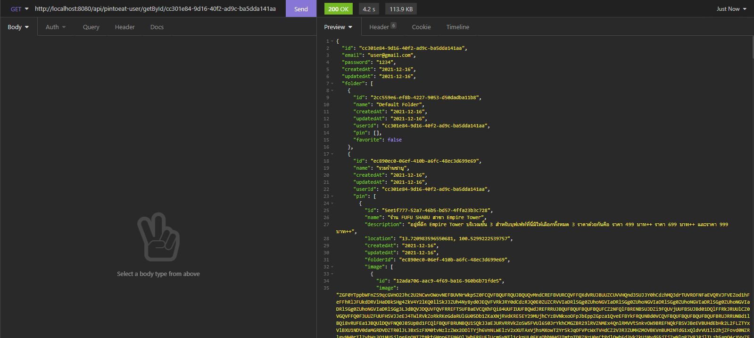

getUserByEmailAndPass: (GET) [http://localhost:8080/api/pintoeat-user/getByEmailAndPassword/{email}/{password}](http://localhost:8080/api/pintoeat-user/getByEmailAndPassword/%7bemail%7d/%7bpassword%7d)

* return user with all folder all pin all image like getUserById

addUser: (POST) <http://localhost:8080/api/pintoeat-user/addUpdate> * set row id = null

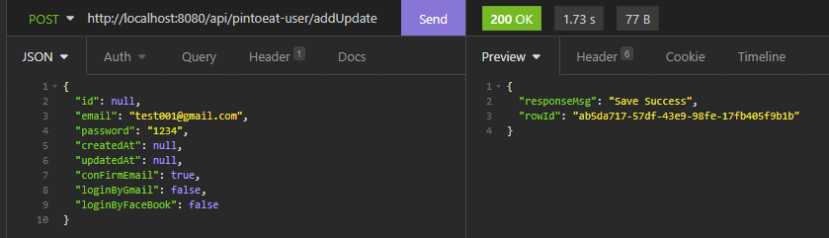

editUser: (POST) <http://localhost:8080/api/pintoeat-user/addUpdate>

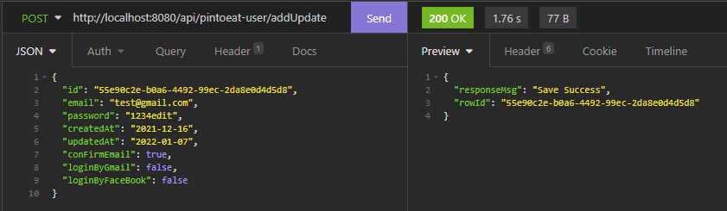

deleteUserById: (GET) [http://localhost:8080/api/pintoeat-user/deleteById/{id}](http://localhost:8080/api/pintoeat-user/deleteById/%7bid%7d)

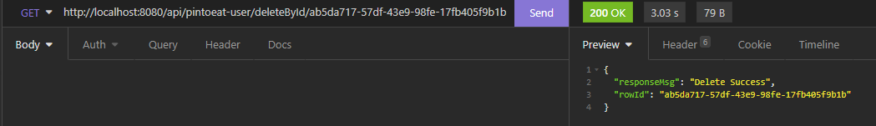

loginUser: (GET) http://localhost:8080/api/pintoeat-user/loginUser/{email}/{password}  
  
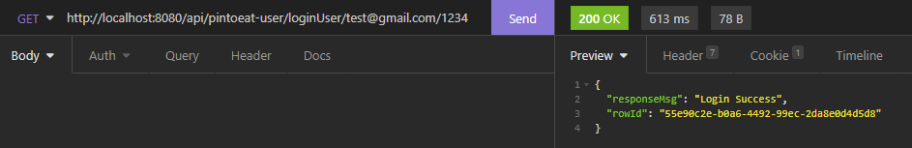

**# Folder**

getAllFolder: (GET) <http://localhost:8080/api/pintoeat-folder/getAll>

* return all folder in table (select * from folder) with all pin all image

getFolderById: (GET) [http://localhost:8080/api/pintoeat-folder/getById/{id}](http://localhost:8080/api/pintoeat-folder/getById/%7bid%7d)

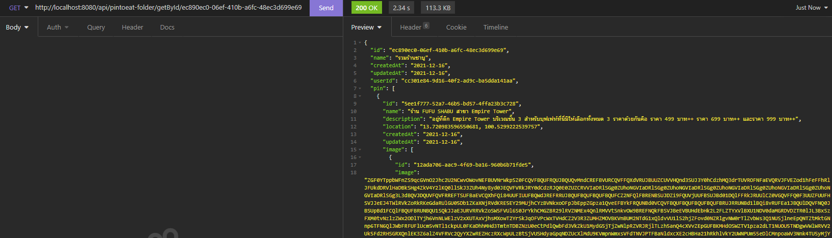

getFolderByName: (GET) [http://localhost:8080/api/pintoeat-folder/getByName/{name}](http://localhost:8080/api/pintoeat-folder/getByName/%7bname%7d)

* return folder with all pin and all image like getFolderById

getFolderByUserId: (GET) [http://localhost:8080/api/pintoeat-folder/getByUserId/{userId}](http://localhost:8080/api/pintoeat-folder/getByUserId/%7buserId%7d)

* return folder list where user id = … with all pin and all image

getFolderOutputByUserId: (GET) [http://localhost:8080/api/pintoeat-folder/getFolderOutputByUserId/{userId}](http://localhost:8080/api/pintoeat-folder/getFolderOutputByUserId/%7buserId%7d)

* return folder with only one pin and only one image priority = 1

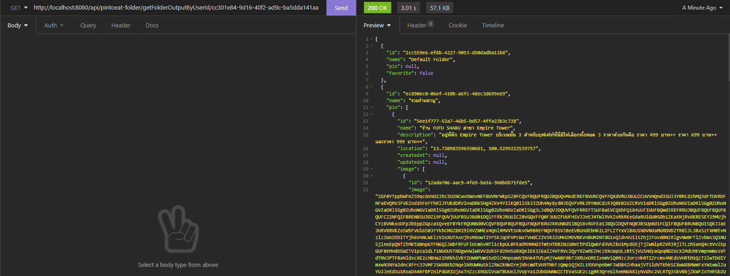

addFolder: (POST) <http://localhost:8080/api/pintoeat-folder/addUpdate> * set row id = null

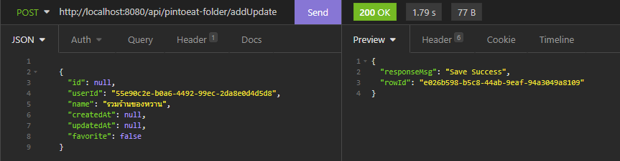

editFolder: (POST) <http://localhost:8080/api/pintoeat-folder/addUpdate>

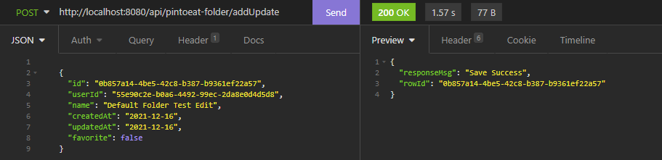

deleteFolderById: (GET) http://localhost:8080/api/pintoeat-folder/deleteById/{id}

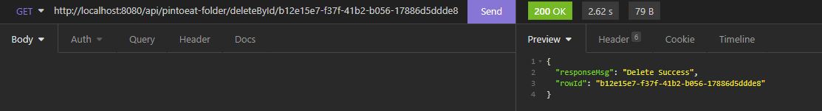

**# Pin**

getAllPin: (GET) <http://localhost:8080/api/pintoeat-pin/getAll>

* return all pin in table (select * from pin) with all image

getPinById: (GET) [http://localhost:8080/api/pintoeat-pin/getById/{id}](http://localhost:8080/api/pintoeat-pin/getById/%7bid%7d)

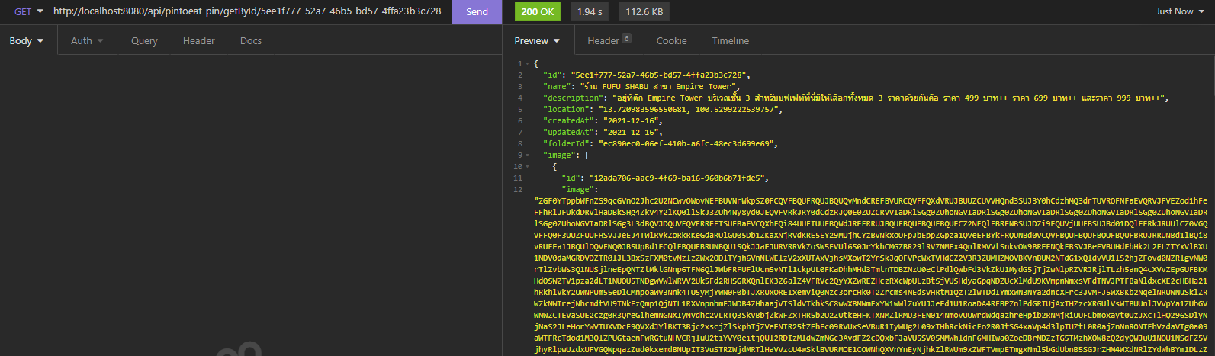

getPinByName: (GET) [http://localhost:8080/api/pintoeat-pin/getByName/{name}](http://localhost:8080/api/pintoeat-pin/getByName/%7bname%7d)

* return pin with all image like getPinById

getPinByFolderId: (GET) [http://localhost:8080/api/pintoeat-pin/getByFolderId/{folderId}](http://localhost:8080/api/pintoeat-pin/getByFolderId/%7bfolderId%7d)

* return pin list where folder id = … with all image

addPin: (POST) <http://localhost:8080/api/pintoeat-pin/addUpdate> * set row id = null

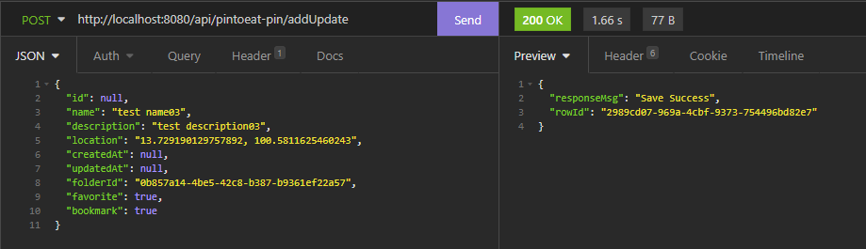

editPin: (POST) <http://localhost:8080/api/pintoeat-pin/addUpdate>

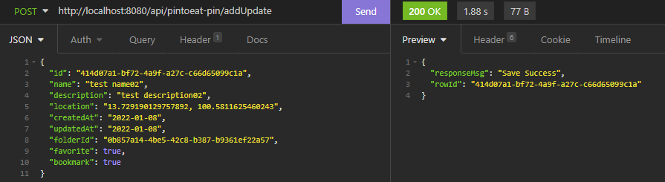

deletePinById: (GET) [http://localhost:8080/api/pintoeat-pin/deleteById/{id}](http://localhost:8080/api/pintoeat-pin/deleteById/%7bid%7d)

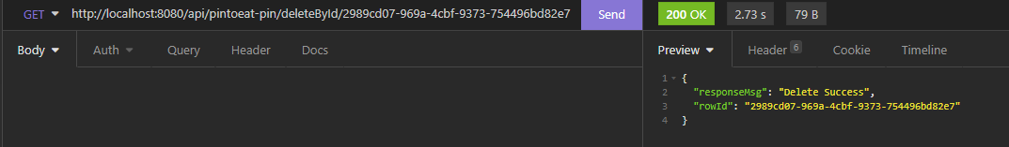

getBookmark: (GET) [http://localhost:8080/api/pintoeat-pin/getBookmark/{userId}](http://localhost:8080/api/pintoeat-pin/getBookmark/%7buserId%7d)

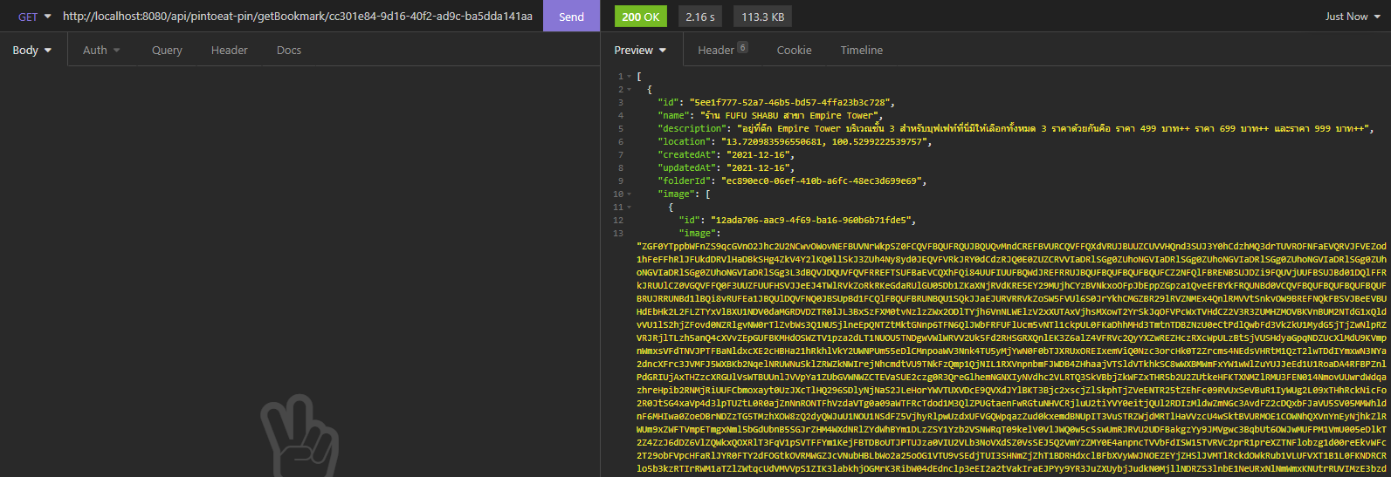

getNearBy: (GET) http://localhost:8080/api/pintoeat-pin/getNearBy/{userId}/{currentLocation}

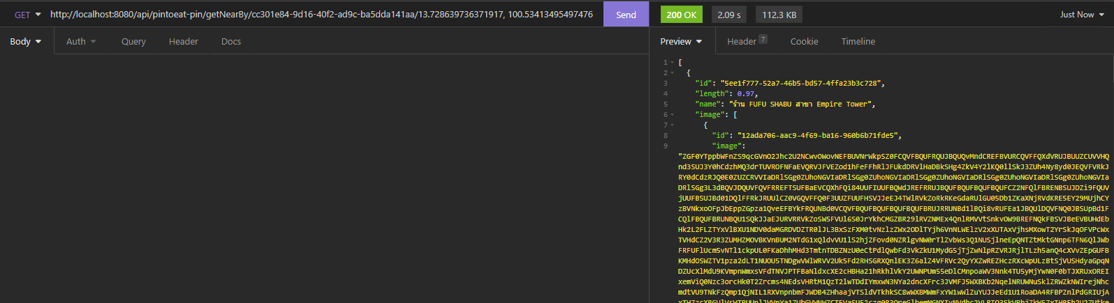

**# Image**

getAllImage: (GET) http://localhost:8080/api/pintoeat-image/getAll

getImageById: (GET) [http://localhost:8080/api/pintoeat-image/getById/{id}](http://localhost:8080/api/pintoeat-image/getById/%7bid%7d)

getImageById: (GET) http://localhost:8080/api/pintoeat image/getByPinId/{pinId}

addImage: (POST) http://localhost:8080/api/pintoeat-image/addUpdate

editImage: (POST) http://localhost:8080/api/pintoeat-image/addUpdate

deleteImageById: (GET) http://localhost:8080/api/pintoeat- image /deleteById/{id}